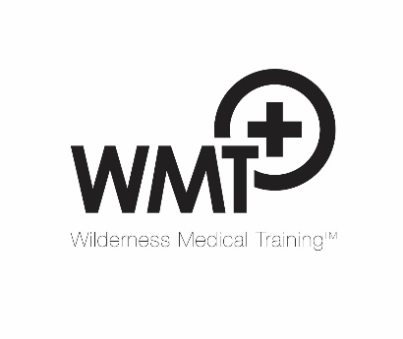
WMT Programme Participation Declaration (14/3/17)

To discharge its duty of care to students and fulfil insurance requirements, WMT requires that all delegates complete this declaration. You must notify us immediately if you have booked a course and cannot agree to this declaration.

- I confirm I am in good health and will not participate under the influence of alcohol, or drugs that will affect my safety or that of others.
- I accept that all the outdoor activities on the programme involve risk and this cannot be completely eliminated even under the supervision of professional instructors.
- I agree to abide by the safety instructions issued by all instructors and confirm that I have taken out adequate insurance for any non-UK WMT event.
- I have disclosed below any medical history and condition(s) that might compromise my health or safety or that of others that the organisers should be aware of when in an outdoor setting in the UK or elsewhere.
- I give the organisers permission to administer medical aid to me should I be unable to give my consent.

My emergency contact is: (name) Contact number(s):

Medical history: please detail any significant past medical history including but not limited to serious injuries, illnesses and current medications (continue on reverse side)

Additional information required for non-UK based courses only:

Full passport name_____________________________________ DOB_________________
Issuing country________________________________
Local embassy tel. ____________________________
Passport number_______________________________
Travel insurance company _______________________Policy number_________________
Insurer’s emergency assistance number __________________________________

Name or signature: Date:

