Injury assessment record form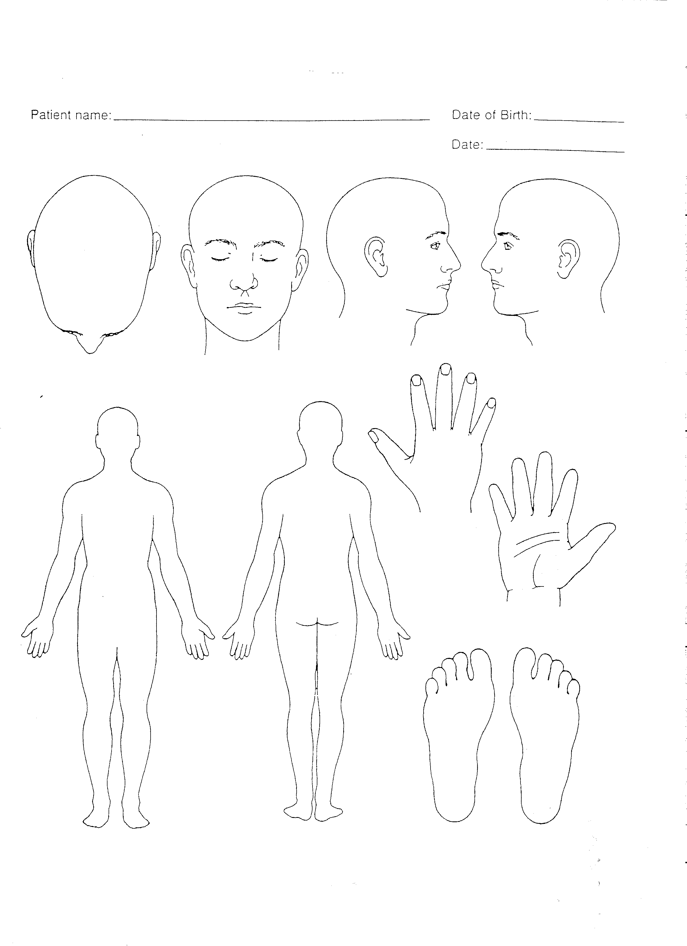

ILLNESS ASSESSMENT FORM

Date/time……………..
Name…………………………………………………Age…………..Occupation…………...…….
History of presenting complaint (in the patient’s own words)
……………………………………………………………………………………………………………
…………………………………………………………………………………………………………………………………………………………………………………………………………………………
………………………………………………………………...

If the patient reports being in pain use the acronym SOCRATES to assess the pain:
- Site - Where is the pain? Or the maximal site of the pain.
- Onset - When did the pain start, and was it sudden or gradual? Include also whether if it is progressive or regressive.
- Character - What is the pain like? An ache? Stabbing?
- Radiation - Does the pain radiate anywhere?
- Associations - Any other signs or symptoms associated with the pain?
- Time course - Does the pain follow any pattern?
- Exacerbating/Relieving factors - Does anything change the pain?
- Severity - How bad is the pain? Score 0-3
Pain notes …………………………………………………………………………………………………………………………………………………………………………………………………………………………
Past Medical History (serious accidents/illnesses, operations, high blood pressure, heart disease, diabetes, asthma, epilepsy)
…………………………………………………………………………………………………………………………………………………………………………………………………………………………
Drugs (oral contraceptives, inhalers, creams, patches)
…………………………………………………………………………………………………………………………………………………………………………………………………………………………

Allergies ..………………………………………………………………………………………
Family History (any significant illnesses in the family, causes of premature death, high blood pressure, heart disease, diabetes)
…………………………………………………………………………………………………………………………………………………………………………………………………………………………
Social History (Tobacco, alcohol, recreational drugs, foreign travel and immunisations)
……………………………………………………………………………………………………………
……………………………………………………………………………………………………………

Direct questions:

Cardiovascular
Chest pain 
Short of breath 
Palpitations 
Ankle swelling 

Respiratory
Cough 
Wheeze 
Sputum 

Gastro-intestinal
Appetite 
Weight 
Nausea/vomiting 
Indigestion 
Abdominal pain 
Bowels

Urino-genital
Dysuria 
Frequency 
Loin pain 
Discharge 
LMP…………………….

Nervous system
Headache 
Eyes/ears 
Weakness/numbness 
Fits/faints 

Examination
General Comments: (unwell, skin colour, sweating, dehydration)
……………………………………………………………………………………………………………

Temperature………………………….ºC
Pulse ………………………………./min
Blood pressure……………./……………

Chest
Laboured breathing 
Respiratory rate ……………/min
Symmetry of chest movements 
Breath sounds (wheezes, crackles, absent) …………………………………..

Abdomen
Distended 
Bowel sounds 
Tenderness (use diagram)

Nervous System

Level of response
Alert 
Verbal 
Pain 
Unresponsive 
Pupils
Equal 
React to light 
Limbs
Movements R ARM  L ARM 
R LEG  L LEG 

Sensation R ARM  L ARM 
R LEG  L LEG 

Possible diagnosis ……………………………………………………………

