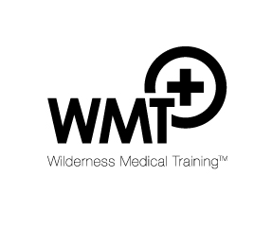
Expedition Medic programme 14 – 15 July 2018, Windermere (3/7/18)
Teaching team: DG - Duncan Gray, CV - Charlotte Verney, BR – Barry Roberts, WH – Wild Human
Timings |  | Instructors
 | Saturday
9.00 - 9.15 | Welcome & staff introductions | BR
9.15 – 10.00 | Bench marking exercise | ALL
10.00 - 10.45 | Expedition medical planning | CV
10.45 - 11.15 | Pain management in the wilderness – discuss over coffee/tea | CV
11.15 – 12.15 | Environmental injury – heat, cold, freezing | DG
12.15 - 1.00 | Lunch
1.00 - 3.00 | GPS & SOS trackers / Jungle living OR WH master class | BR / WH
3.00 | Break
3.30 – 4.15 | Tropical problems | CV
4.15 – 5.00 | Altitude illness & PAC | CV/DG
 | Evening seminar to be confirmed
 | Sunday (strike personal tents & pack up before classes start)
8.45 – 9.30 | Medical kit discussion | DG
9.30 – 12.00 | 3 session rota - wilderness orthopaedics / trauma / rope work
12.00 – 12.45 | Lunch
12.45 – 2.00 | Rota continued | ALL
2.00 - 2.45 | Life as an expedition medic – insight talk | CV
2.45 | Break
3.00 - 3.15 | So you wanna be an expedition medic? | ALL
3.15- 4.00 | Final questions, evaluation, certificates, close, depart camp 4pm | ALL

