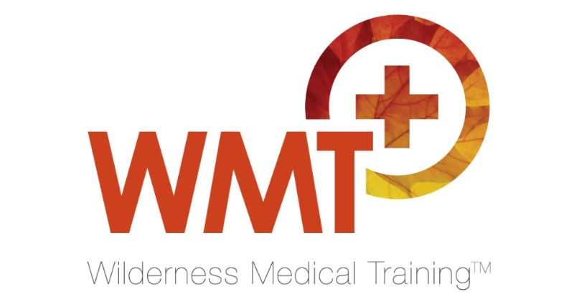
Notes on the medical content of the 2025 Morocco Max Mountain Medicine Expedition
The primary objective of the expedition is to train, teach and prepare doctors to practice medicine in the mountain environment. We believe this experience also makes better, more well-rounded doctors who may be working in hospital, remote communities or in domestic settings outdoors (as emergency medics on the roads or outdoor events, festivals etc.) The outdoor doctor is resilient, adaptable and able to improvise to provide effective care in physically challenging and resource poor conditions and better able to advise patients travelling to remote places.
WMT’s Morocco expedition is a demanding undertaking because there is very little free time. The educational content will be interspersed pre and post trekking activities and while on the trail (with focussed questions to discuss on the move) so that time spent learning is optimised whatever the format, including:
- Lectures – PowerPoint presentations are displayed on a laptop or they are shared as PDFs to participants for reference on their phones
- Tutorials & discussion groups, case studies
- Practical teaching – medical techniques out of hospital
Medical instructor
Dr Anna Wallace is the WMT medical tutor on the expedition. She has a vast amount of foreign travel and clinical experience and holds the UIAA Diploma in Mountain Medicine. She is an emergency medicine doctor in the south of England. Her remote clinical work ranges from running a snake bite clinic in Tanzania to mountain medicine work in Nepal. Anna is supported by the expedition leader Barry Roberts who has completed 40+ major expeditions, often in the combined capacity of leader and medic. The 2025 expedition is limited to 12 participants to maintain the integrity of the medical training component.
Learning support materials
Participants receive a comprehensive course manual (200+ pages) that includes the expedition content plus much more medical material (tropical medicine, dentistry and diving medicine for example). Post-expedition, a further study guide of relevant research papers and reference sources is issued so that delegates may consolidate what they have learned and further enrich their understanding of the special topics covered.

Following is a broad outline of the medical topics covered on the expedition.
Medical planning and pre-travel considerations
- Expedition medical planning inc medical indemnity, scope of practice & the role and responsibilities of the expedition medic
- Medical screening of participants
Mountain Medicine – lectures, cases
- The 3 syndromes of altitude illness – AMS (acute mountain sickness), HACE (high altitude cerebral oedema), HAPE (high altitude pulmonary oedema)
- High altitude physiology
- Relevant medications
- Advising and preparing participants going to high altitude
- Everest case study – by the expedition leader Barry Roberts
Environmental medicine
- Hypothermia – recognition & treatment
- Non freezing cold injury & frostbite – recognition & treatment
- Hypothermia mitigation strategies & equipment
- Heat injury - recognition & treatment

Managing injuries in the field
- Managing trauma in the wilderness
- Practical fracture management
- Managing ankle sprains
- Reducing the dislocated shoulder
- Spinal injuries – can you clear the neck in the wilderness setting?
- Patient packaging, moving patients, working around helicopters

Other important topics – discussions & tutorials
- Expedition mental well-being
- Medical kits – compiling a suitable medical kit - where to start
- How to further a career in wilderness and expedition medicine

For further information please see https://wildernessmedicaltraining.co.uk/medics-series-courses/morocco-max-expedition/ or contact Barry Roberts by email wmt@wildernessmedicaltraining.co.uk

